# Request for Proposal

Group Project Participates:

* Wouter Moedt wmoedt@unomaha.edu
* Harwinder Kaur hharwinderkaur@unomaha.edu
* Brandy Bergmann bbose@unomaha.edu
* Danial Faisal dfaisal@unomaha.edu
* Hitesh Kumar Khatri hkhatri@unomaha.edu
* Ranga Tanishk Reddy rreddy@unomaha.edu
* Kim Duong kduong@unomaha.edu

Data Visualization

University of Nebraska at Omaha

# Abstract:

Immigration is currently a hot topic in the United States right now. We want to take an exploratory approach to understand the data that is available for migration. We are a diverse group of individuals representing several countries from several continents. Along this journey, we hope to find correlations to migration and visualize the flow of immigration across the world and understand the factors leading to immigration.

# Problem Statement:

The purpose of this project is exploratory in nature.

1. What is the flow of Immigration across the world? We will evaluate rate, ranks, and fluctuation in volume over time; who’s migrating (by gender and age),
   1. What are the factors leading to immigration? IE is there a correlation to economic growth, climate change, corruption index and immigration policy on immigration and is it predictable based on historical rates of immigration.
   2. What are the economic benefits of immigration?
      1. Impact on GDP (gross domestic product):
      2. Impact on GNI (growth national income):
      3. Impact on NNI (adjusted national income)
   3. What is the impact of climate change on migration?
      1. Impact on agriculture:
      2. Impact on water and sanitation:
   4. What is the impact of the corruption index on immigration?
      1. <Since we’re recreating this graph for Assignment 2 it may be reasonable to look for a correlation to immigration>
   5. What national and international policies accelerate or restrict immigration?
      1. Who hosts the largest volume of migrants, who hosts the least?
      2. What is the annual rate of change in international migration?
   6. Is Illegal immigration really an issue?
   7. What is the difference between refuge/asylum immigration and full legal immigration?

# Background:

# Data Sources:

# Project Goal and Scope:

We would like to create a graph that is similar to this in nature that would allow us to look at factors and potential correlations overlaid onto a an interactive geospatial map with our factors including: economic opportunity, climate change, policies, and corruption index.

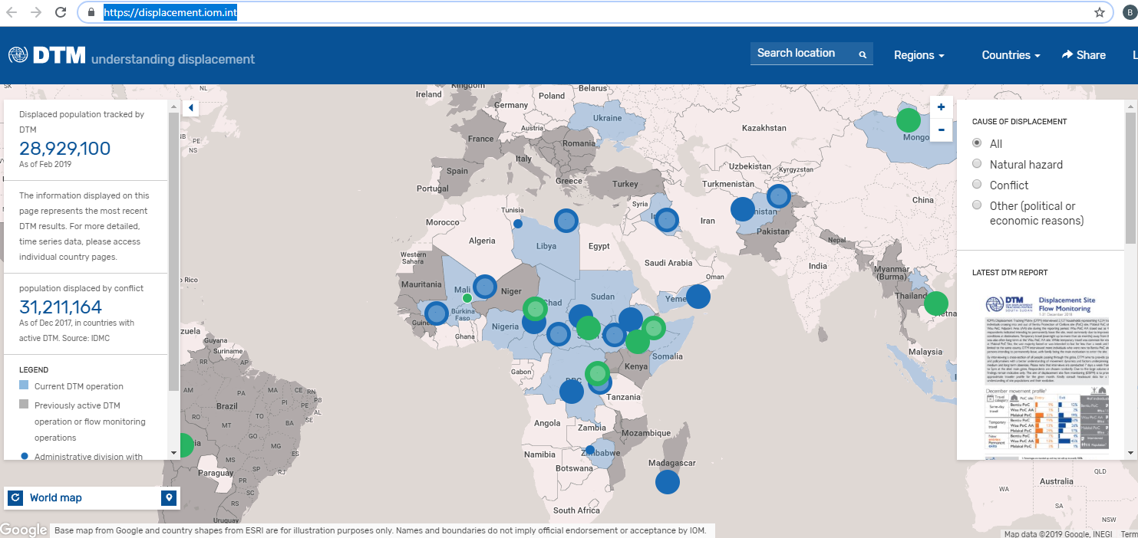

# Potential Roadblocks:

# References:

Environmental:

<https://iopscience.iop.org/article/10.1088/1748-9326/7/1/015601/meta>

<https://onlinelibrary.wiley.com/doi/full/10.1002/wcc.54>

<https://migrationdataportal.org/themes/environmental_migration#data-sources>

<https://environmentalmigration.iom.int/migration-environment-and-climate-change-evidence-policy-meclep>

<http://www.fao.org/3/CA1487EN/ca1487en.pdf>

<http://www.fao.org/statistics/en/>

<https://www.migrationpolicy.org/research/climate-change-and-migration-dynamics>

<https://www.ethz.ch/en/news-and-events/eth-news/news/2018/02/bernauer-koubi-climate-change-migration.html>

economic:

<https://clas.berkeley.edu/research/immigration-economic-benefits-immigration>

<http://knowledge.wharton.upenn.edu/article/economic-debate-immigration-reform/>

refugee:

<https://www.cgdev.org/media/developing-countries-are-bearing-most-responsibility-hosting-refugees>

general:

<https://displacement.iom.int/>

<https://news.un.org/en/story/2018/12/1028041>

Potential data sources:

<http://www.fao.org/faostat/en/#data>

<http://www.fao.org/fishery/statistics/collections/en>

<http://www.fao.org/economic/est/statistical-data/en/>

<https://catalog.data.gov/dataset/global-surface-summary-of-the-day-gsod>

<https://stats.oecd.org/Index.aspx?DataSetCode=MIG>

https://www.cgdev.org/publication/dataset-vulnerability-climate-change